1. 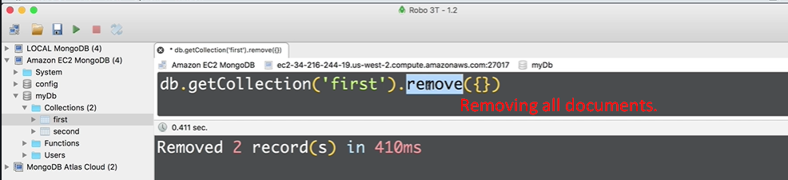
2. 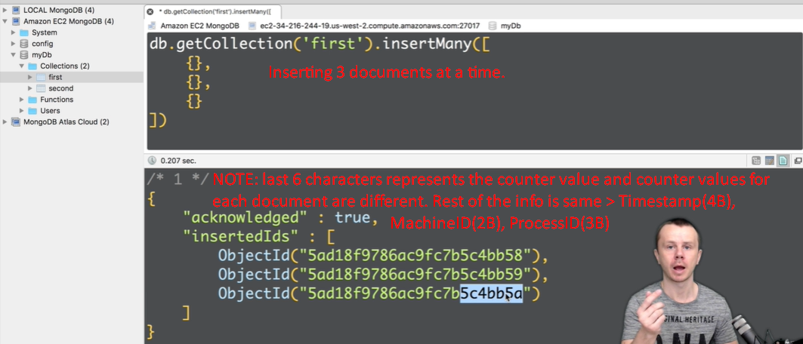  
   **NOTE**: They are same because, we’re inserting all 3 documents at a time and on same machine and under same process.